Notes for Node JS app

1. Start the Node server and run the app using below command:

Goto the project directory where your package.json file is there >> run the command “npm start” in cmd >>

1. Create Folders with below strucures:

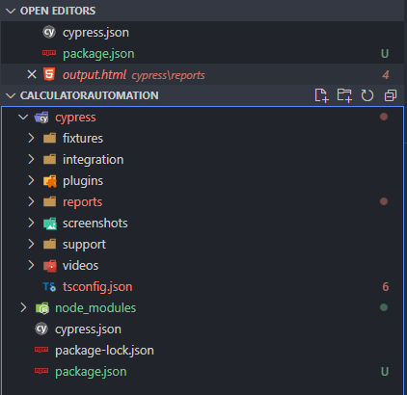

Fixtures: Add details to do data driven testing

Integration: integration folder provides a place that writes out test cases with further more folder structure based on functionality as below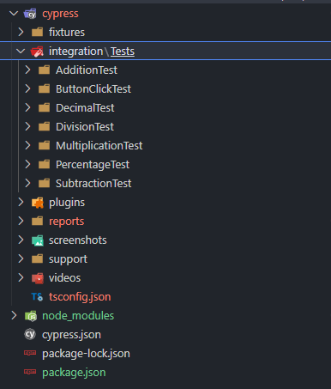

**Plugins**: Plugins contain the plugins or listeners. By default, Cypress will automatically include the plugins file "cypress/plugins/index.js" before every test it runs.

**Reports**: To keep generated different kinds of reports like json, mochawesome HTML etc.

**Screenshots**: Folder Contains the test failure screenshots.

**Videos**: Folder contains the videos of test case execution of each tests.

**Support** : Support writes customized commands or reusable methods that are available for usage in all of your spec/test files. This file runs before every single spec file.

**Here I used POM base approach although it is not suitable for this as it contains only one page**.

**But still used it to segregated the elements with the its actions**.

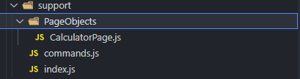

**Node_Modules** : Node_Modules in the default project structure is the heart of the cypress project. All the node packages will be installed in the node_modules directory and will be available in all the test files.

**Cypress.json**: Cypress.json is used to store different configurations. E.g., timeout, base URL, test files, or any other configuration that we want to override for tweaking the behavior of Cypress. We can also manage the customized folder structure because it is part of by default Cypress Configurations.